Week 2

Living & Non-Living

Instructions: Carefully read the learning intentions and the success criteria, these are the goals of the week. Read to the content section, take notes and answer the questions on page 5. To complete the two labs read the instructions carefully and answer the questions using either a word document or hand draw a dichotomous key and take a photo or scan in the image. To complete the ICT activity, follow the link and access the online game. Use the additional resources if you require them and ask any questions as necessary.

Learning Intentions: This week we are learning about the characteristics of what makes something living or non-living.

Success Criteria:

- Know the characteristics of a living thing.
- Identify if something is non-living or dead.
- Be able to use a dichotomous key.
- Be able to create a dichotomous key for a given collection of organisms.

Background:

For relevant background information on dichotomous key’s access the week 1 workbook through connect.

In week one we explored the Linnaean Classification system, dichotomous keys and scientific naming.
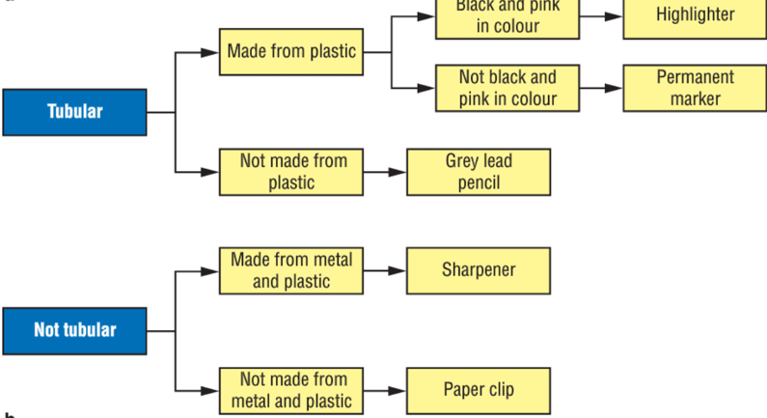
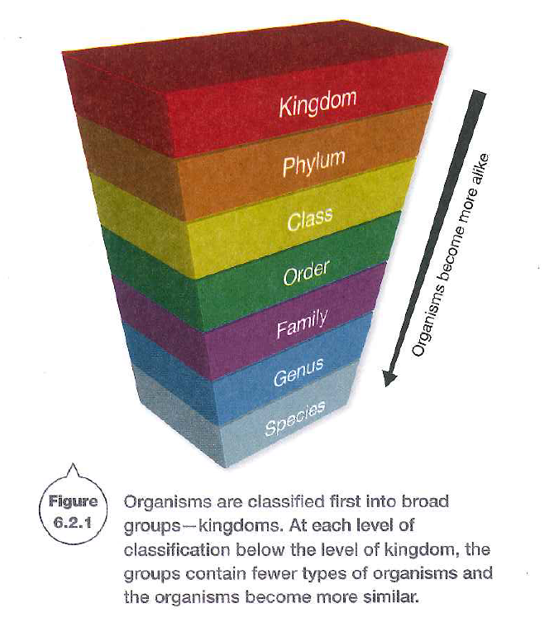
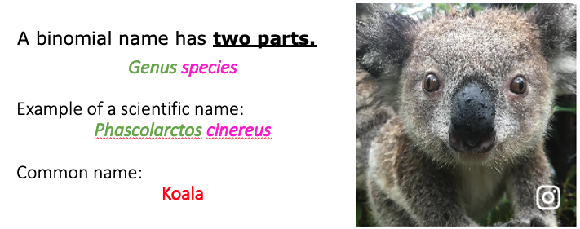

Content

Living Organisms have characteristics in common

Biology is the study of living organisms and what it means to be alive. Both plants and animals are considered to be alive. They share many characteristics that apply only to organisms.

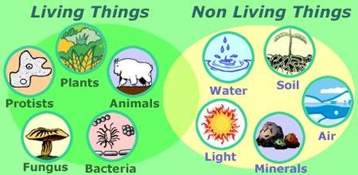
Living and non-living

One of the first decisions most scientists have to make when classifying something for the first time is if it alive. What does it mean to be alive? What is the difference between us and the desk we are sitting at? Both plants and animals are considered to be alive. What do we have in common that makes us alive?

Characteristics of living things

It has taken many years of observation and discussion for scientists to develop eight characteristics that all living things – plants, animals and even microorganisms like bacteria have in common. To remember all eight characteristics, just remember MR N GREWW.
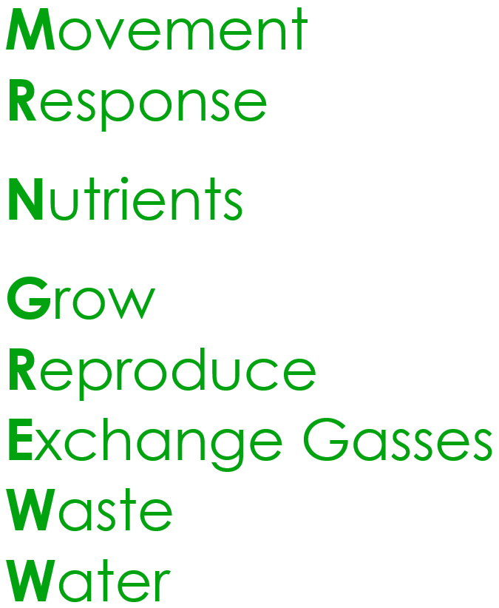
MR N GREWW stands for:

Movement
Reproduce
Nutrition
Grow
Respond
Exchange Gas
Waste
Water

M Living things can MOVE by themselves
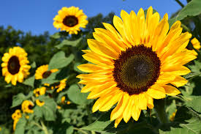
Cats chase mice, birds flap their wings as they fly, and fish swish their tails as they swim. Animal movements are easy to see. But do plants move? Look at the leaves of an indoor plant- they usually face the window (a source of light). Turn the plant around so that the leaves face into a darker part of the room. In a few days, the leaves will again be facing the window. The leaves have moved by themselves. Sunflowers turn their heads to follow the sun as it moves across the sky each day.
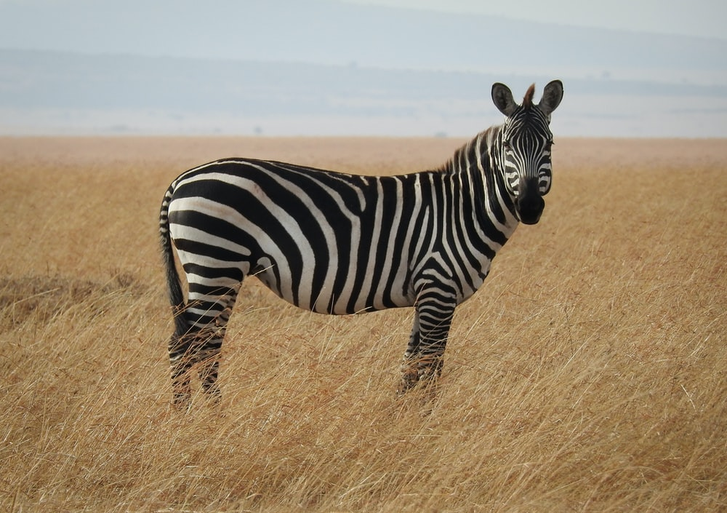
R Living thing can REPRODUCE

Living things can make new individuals that grow up to look like them. Animals mate and produce offspring, plants produce seeds that grow into new plants, and bacteria divide to produce more bacteria. Reproduction is the process by which living things make new life.

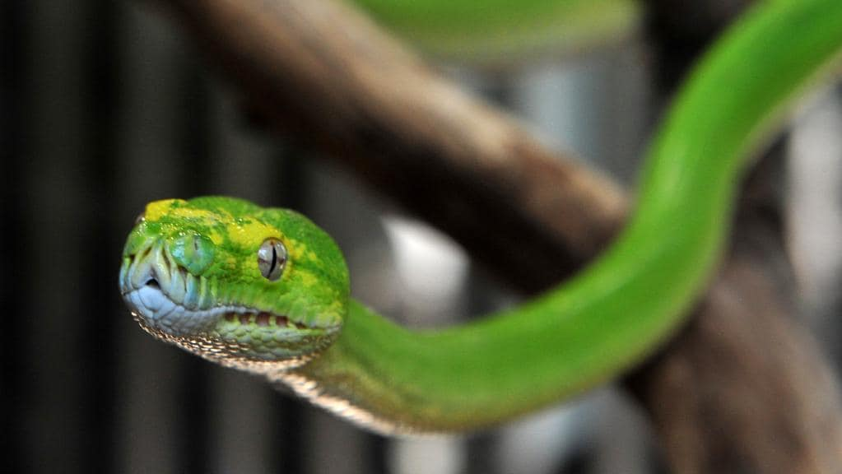
N Living things need NUTRITION

All living things need to survive. Animals obtain most of their nutrients by eating food and drinking. Plants absorb nutrients through their roots and fungi feed on decaying organisms. Plants are autotrophs, which means that they make their own food. Animals and fungi are heterotrophs – they rely on other living things for food.
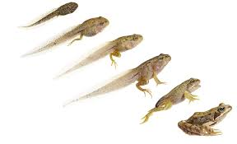

G Living things GROW as they get older

All living things grow during their lives. Mushrooms start off as tiny spores. Humans are born as babies, developing into children, teenagers and then adults. Insects hatch from eggs as larvae, then metamorphose into adult insects. In every case, living things, when fully grown, resemble those who produced them.

R Living things RESPOND to stimuli

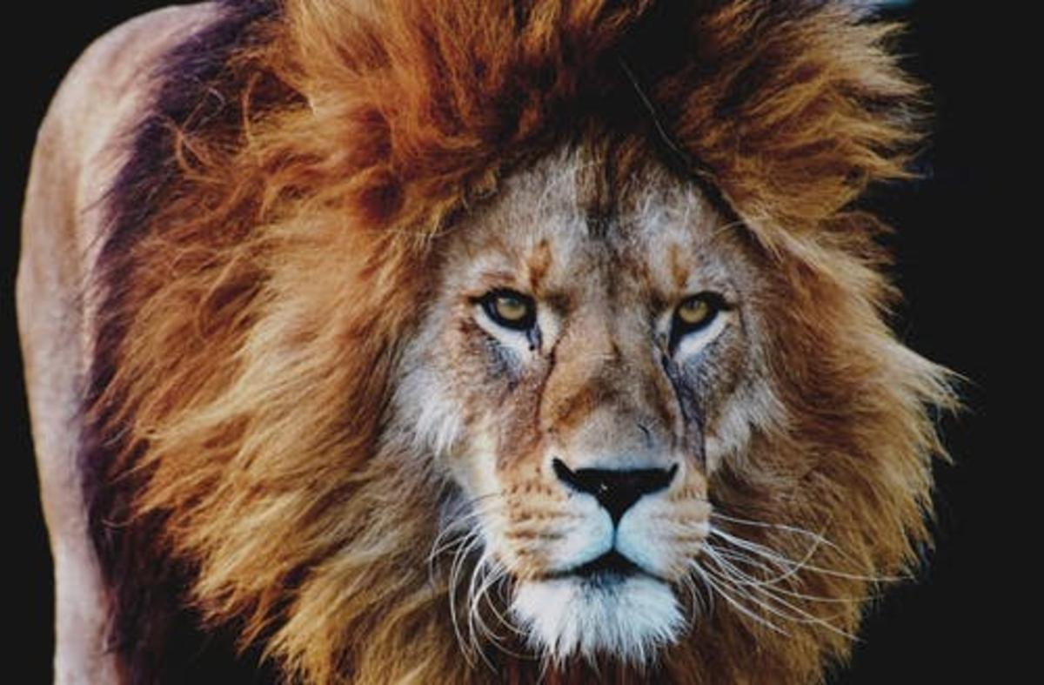
When an animal realises it is being chased, like an antelope, it runs. It is responding to stimuli (the sight and sound of a charging predator or to changes in its environment (the sudden brush of leaves or movement of shadows). The sunflowers shown above, are responding to the changing stimulus of light and warmth. When you accidentally brush your finger against something hot, like an iron, you pull back – your body is responding to the stimulus of heat.

E Living things Exchange gases with their environments

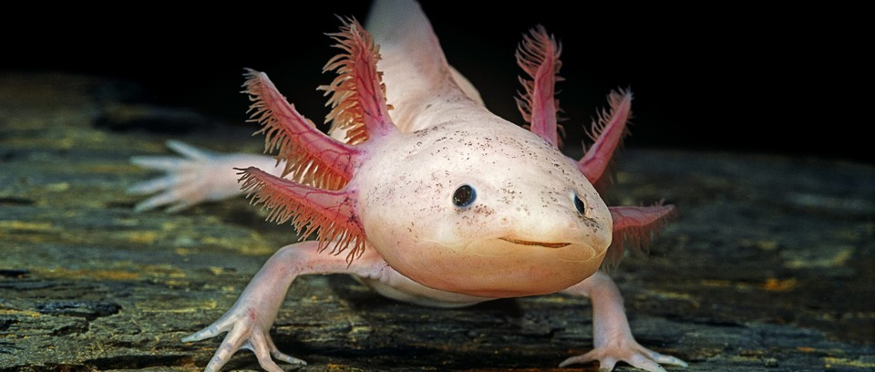
Plants and animals have organs and structures that allow them to exchange oxygen and other gases. Some animals, like humans, use their lungs to inhale and then exhale. Other animals, like fish and axolotl, have gills. Some animals like worms, breathe through their skin. Bacteria are different to plants and animals: they do not have organs, but they still exchange gases. Some types of bacteria die in the presence of oxygen but use and produce other gases.



W Living things produce Wastes

We, like other animals, take food, water and air to fuel our bodies. Chemical reactions occur in our bodies and wastes are produced as a result, we get rid of these by exhaling, sweating, urinating and digestating (emptying our bowels). Plants ger rid of their wastes through their leaves.

W Living things require Water


All living things need water; it is required for many jobs. For example, it transports substances in our bodies to where they are needed, and it is involved in many important chemical reactions that must take place. In animals such as humans, it helps maintain body temperature. No wonder a large proportion of our body is water!

Non-living or dead

Something classified as living needs nutrition and water, and is able to move by itself, reproduce, exchange gases, grow, respond to stimuli and produce waste.

If something doesn’t have these characteristics, it would seem logical to assume that the thing is non-living. But, what about something that is dead? Something dead, such as dried flower or an Egyptian mummy, was once living when it is alive it did have the characteristics of a living thing. Something that is non-living, such as a computer or your watch, never had these characteristics.

Questions

- The system scientists use to group things divides them first into two groups. What are the two groups?

- Consider the table below:

- Decide if each of the items meets the requirement to be classified as a living thing.
- Decide if each should be classified as living or non-living.

 | Eucalypt Tree | Water | Paper | Robot | Leather Belt | Wombat | Roast Chicken
Moves by itself
Reproduces itself
Requires nutrition
Grows as it gets older
Responds to changes in its environment
Produces waste
Requires water
Living or non-living?

- Are any of the items in the table above dead? Explain your answer.

- A mnemonic (pronounced ‘mnem-on-ic” is a memory aid. It is an especially good way to remember a list. A mnemonic takes the first letter of a word in a list and uses the letters to start words in a phase.

For example, the colours of the rainbow (red, orange, yellow, green, blue, indigo and violet) could be remembered using the phrase Rich Old Yankees Go Bowling in Vienna.

Write a new mnemonic to help you remember the eight characteristics of living thing. You may change the order of the characteristics to help you make a phrase.

- Use the characteristics of a living thing to describe a bushfire.

- Is a bushfire alive? Explain your answer.

Lab 1

Beetle Dichotomous Keys

Instructions: Use the beetle dichotomous to answer the questions below.

Question: Use the dichotomous key in the figure 1. below to help with the following tasks.

- Identify and name the four beetles in figure 2. 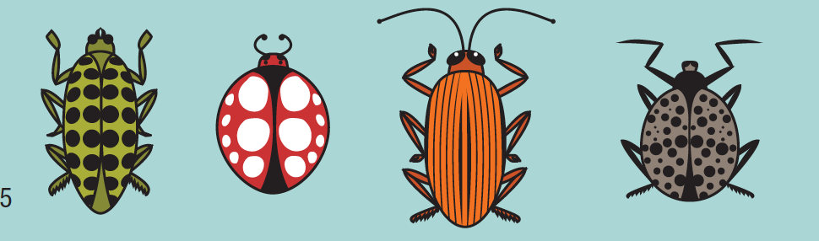 Figure 2.
- Draw a simple sketch of the following:
- Frope Beetle
- Gring Beetle
- Gripe Beetle
- Frong Beetle

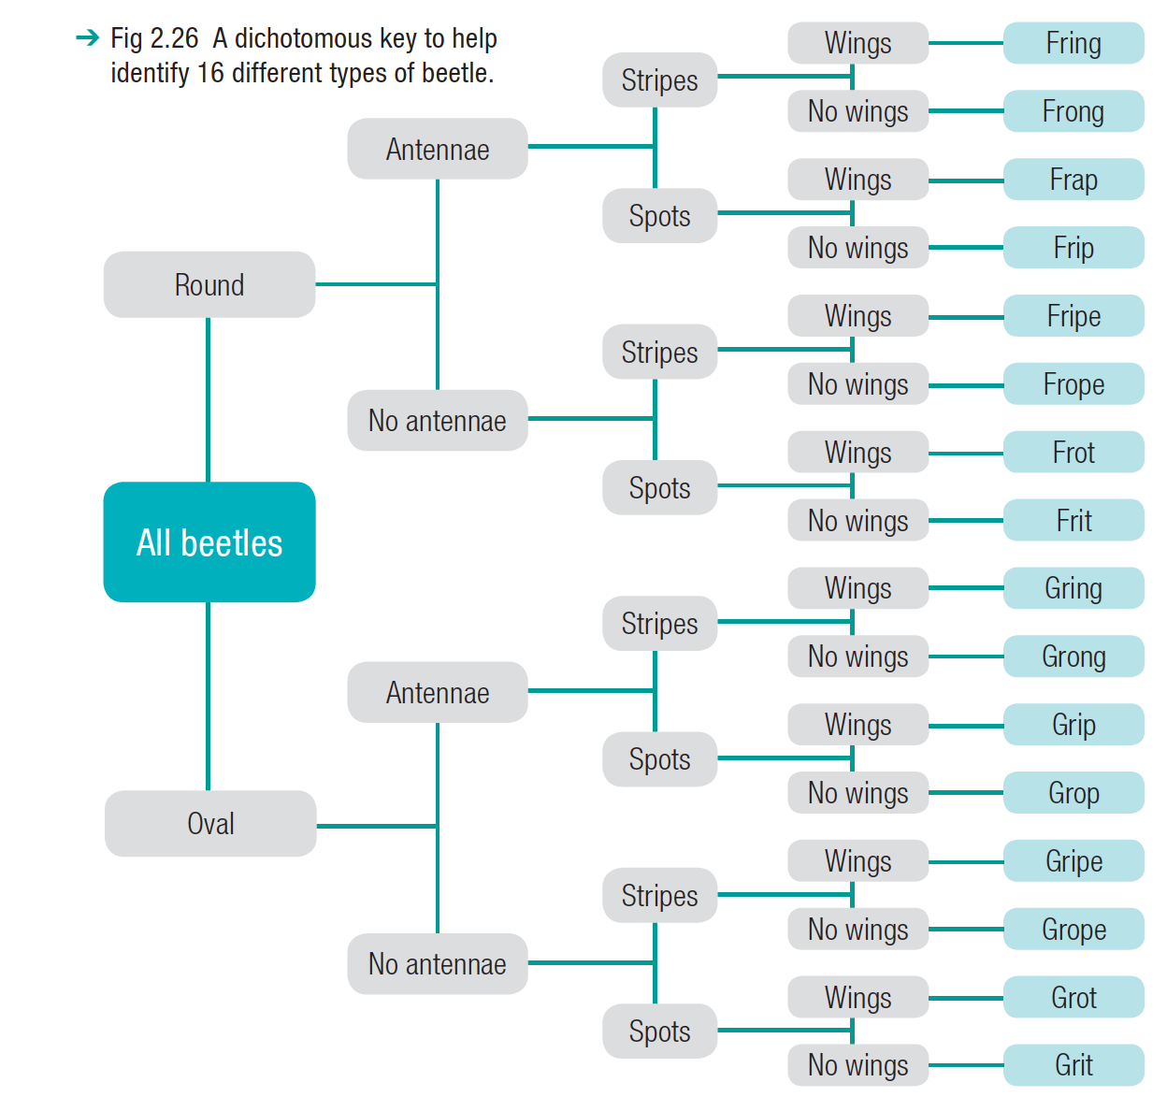Figure 1

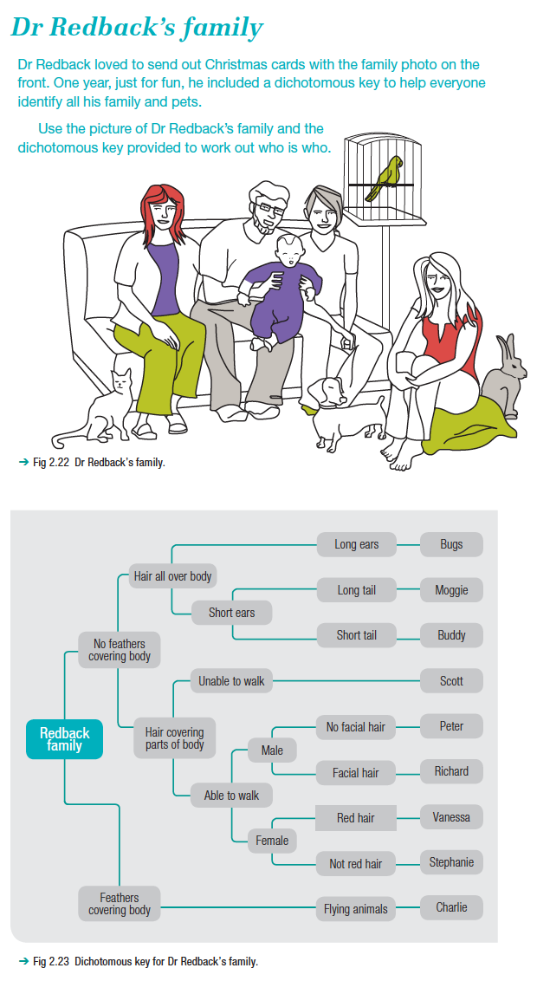

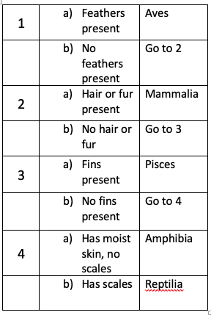
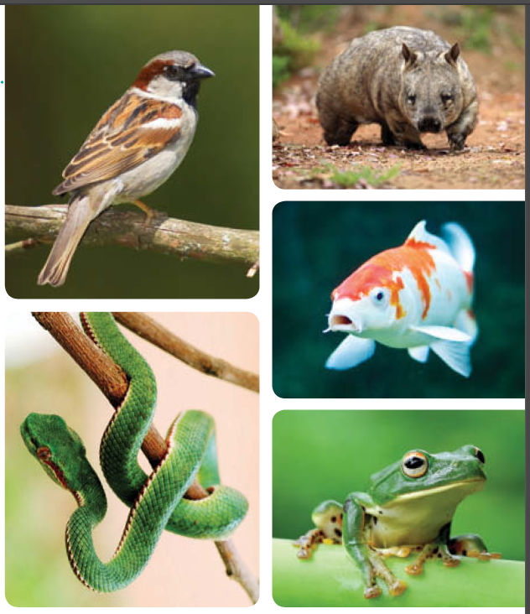
Lab 2

Using and Creating Tabular Keys

Using a tabular key

Scientists often use tabular keys to determine the group an animal belongs to. These keys are set out where you read through the numbered options in order. Each item presents two options, and more information is given at each step. Eventually the animal can be identified.

- Use the information given above in the picture of the 4 organisms and the table to the right of the picture to identify the class of each of the animals shown.

- Using the Dr Redback’s family picture and dichotomous key, create your own tabular key to identify all the living things in the image.

ICT Activity

Instructions: Access the link below and play the classification game.
http://sciencenetlinks.com/interactives/class.html

Summary
- Biology is the study of living organisms and what it means to be alive. Both plants and animals are considered to b alive.
- An organism that is alive must have eight characteristics. They are:
- Movement
- Reproduction
- Nutrition
- Growth
- Respond
- Exchange Gas
- Waste
- Water
- Something that is living needs to display all eight characteristics.
- Something that once did display these characteristics is considered dead.
- And something this non-living never ever displayed those characteristics.

If I wanted to learn more I could go to:
https://eol.org/
https://www.youtube.com/watch?v=lnvlMlopu2A

Glossary

Autotrophs
Organism that male its own food (e.g. plants)

Heterotrophs
Organisms (e.g. fungi) that need to absorb nutrients from other living things.

Non-living
Something that has never had the characteristics of a living thing.

Living
Needs all the characteristics of MR N GREWW.

Dead
Something that was once living but no longer has the characteristics of a living thing.

References

Pearson Science 7. (2011). Melbourne, Australia: Pearson

Nelson iScience. Year 7: for the Australian curriculum. (2011). Melbourne, Australia: Cengage Learning

Silvester, H. (2015). Oxford Science 7. Melbourne, Australia: Oxford

Williamson, K. (2011). Science Essentials 7. Melbourne, Victoria: Macmillan Education

